Z:\All folders 2014\COMMUNICATION UNIT\LOGO_2014 and letter heads\undp_logo_new_eng_96dpi.jpg 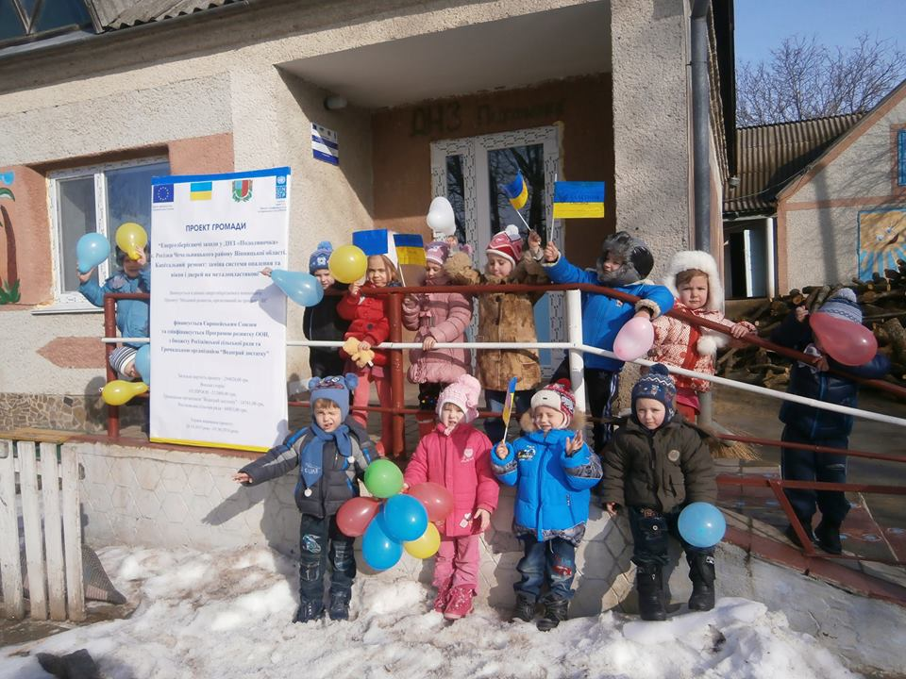

The CBA Project in Vinnytsia Region: Factsheet

The largest cities and towns of the region are Vinnytsia, Zhmerynka, Koziatyn, Ladyzhyn, Mohyliv-Podilskyi and Khmilnyk.

Vinnytsia region is largely dominated by agriculture. The main products grown in the region are winter wheat, barley, sunflower, corn, buckwheat, millet and sugar beet. Cattle breeding is also important. The region has also important industrial sectors. The region has a multisectoral industrial complex, where leading places are held by the food industry, machine building and metalworking.

Vinnytsya region is central part of Ukraine. It borders with such regions as Chernivtsi, Khmelnytskyi, Zhytomyr, Kyiv, Cherkasy, Kirovohrad and Odesa, as well as with Moldova on the southwest. Vinnytsia region territory occupies 4.4% of the total area of Ukraine with a population of about 1.6 mln. About 51% of the region population lives in cities and towns.

Vinnytsia region includes 27 rayons, 18 cities, 29 urban villages, and 1,457 villages.

KEY DATA ON

THE CBA-I and CBA-II PROJECT IN VINNYTSIA REGION

**Vinnytsia region background**

Updated 28 March 2016

Beneficiaries

61 670 men, women and children

CBA Microprojects in Vinnytsia region

38 schools / kindergartens

9 health posts

8 water supply

8 street-lightning

The CBA-II Coverage in Vinnytsia Region

**The CBA Implementation in Vinnytsia Region**

Implementation of the first phase of CBA Project commenced in Vinnytsia region during April 2008. First phase was succeeded by a second phase in August 2011. Over these two phases 61670 of men, women and children of the region have benefitted from improvement in 38 schools/kindergartens, 9 health posts, 8 water supply, 8 street-lightning and so on. This happened through joint effort of the citizens, oblast/rayon/local level governments, the CBA Project and the private sponsors.

***Third Phase of the CBA Project***

***Third phase of the CBA III*** was initiated in Vinnytsia region with regional launching and signing of MoU which took place on September 30th, 2014. The region received a quota of 8 rayons for standard\replication components.

Rayons selected for the CBA-III: *Yampilskyi, Orativskyi, Chechelnytskyi, Barskyi, Illinetskyi, Mohyliv-Podilskyi, Tomashpilskyi, Kalynivskyi.*

***Micro projects approved as of 28 March 2016****:* *18 micro projects (12 – energy saving, 3 – energy efficiency, 3 – rural economic development).* Around 7, 350 persons will benefit from implementation of these initiatives. Total budget for the initiatives is approx. UAH 7.2 mln (approx. USD 264, 200). UNDP will provide around UAH 4.6 mln (approx. USD 168, 800).

**UNDP/CBA support for Internally Displaced Persons**

The CBA Project has supported 1 micro projects in the region aimed to address this issue: major repair of *Dnister* Hotel in Yampil city, for a total amount of more than UAH 1.3 mln (USD 47,700), out of this EU\UNDP share is more than UAH 1 mln (USD 36,700). In *Dnister* Hotel, new windows and doors were installed; heating system, internal water supply and sewage were renovated; finishing works were done. In the refurbished building around 40 IDPs will find a shelter.

[www.cba.org.ua](http://www.cba.org.ua)

20 Esplanadna Str., office 704-708, Kyiv Tel: +38 (044) 253 5975 Facebook: www.facebook.com/cbaproject

**CBA Community** **Development Officers, Vinnytsia Region**

Anastasiya Lanina

mob. tel: (050) 416 37 89



Natalia Karpenko

mob. tel: (050) 381 89 13

